**PROJECT REPORT**

*ORIENTED PROGRAMMING LAB (CSL-210)*

# MATCH TICKET BOOKING SYSTEM



**BS (CS)-2A SPRING 2022**

*Group Members*

|  |  |
| --- | --- |
| **Name** | **Enrollment** |
| 1. **Arham Tanveer Mallick** | **02-134212-028** |
| 1. **Mania Imam** | **02-134212-013** |
| 1. **Areeb Ur Rehman** | **02-134212-015** |

**LAB INSTRUCTOR: Ms. SALAS AKBAR**

**COURSE INSTRUCTOR: Ms. SAMEENA JAVAID**

**BAHRIA UNIVERSITY KARACHI CAMPUS**

*Department of Computer Science*

**INDEX**

Chapter 1 …………………………………………………………5

1. **Introduction**……………………………………………….5
   1. Intro……………...……………………………………5
   2. Project description……………………………………5
   3. Team profile…….……………………………………5

Chapter 2 ………………………………………………………..6

1. **Uml and Flowchart** ………………………………………6
   1. UML diagram..…………………………………………6
   2. Flowchart………………………………………………..8

Chapter 3………………………………………………………..6

1. **Database Explanation** ………………………………………6
   1. ..…………………………………………6
   2. ………………………………………………..8

Chapter 4………………………………………………………..6

4. **Forms and Explanation** ………………………………………6

* 1. Login Form..…………………………………………6

4.2 Sign Up Form………………………………………………..69

# 

Chapter 5………………………………………………………..6

5. **Code Snippets……**………………………………………6

5.1 ..…………………………………………6

5.2 ………………………………………………..69

Chapter 6………………………………………………………..6

1. **Conclusion ………….**………………………………………6
   1. ..…………………………………………6
   2. ………………………………………………..8

# CHAPTER 1

1. INTRODUCTION TO SYSTEM

## *1.1 Intro*

This project was designed to minimize manual labor. The Online Movie Ticket Booking System will allow access to all stadiums around the city. The user will be able to book seats and make online payments for a particular match that will ultimately save time by not visiting the stadium in person and waiting in line. Having a website makes it easier for clients to make reservations and get informed with details regarding the matches and availability of seats. This is a highly developed and easy-to-use project that gives convenience to the user and and the company employees

## *1.2 Project Description*

The online movie booking system is an automated website system that is easily controlled by the developers and the owner himself. Users can find out about match details, ticket availability and its price, times, stadium location and seat information. They can check ratings and book their tickets at any time as the system provides 24/7 service to users. Option for booking VIP seats are available too.

The main purpose of the online match ticket booking system is to provide the owner with a place to manage the entire booking system with a single web page. In addition, it also offers many benefits to users. They can check the details of a particular match at any time and complete their tickets for any event anywhere.

## *1.3 Team Profile*

In the development of this project all team members are fully involved and working on the project to the best of their ability. Tasks were divided accordingly by group members accordingly

|  |  |  |
| --- | --- | --- |
| **Name** | **Enrollment** | **Task** |
| 1.Mania Imam | **02-134212-013** | Has a good grip on coding, project management which includes leadership qualities and the execution of the project and contributed in GUI of forms in this project . applied knowledge of UML and concepts of OOP in the project on the code. |
| 2.Arham Tanveer Mallick | **02-134212-028** | Has great management skills and contributed with knowledge of OOP. A great workload manager and documentation in addition to contributing in the source code. Contributed to the GUI of the stadium in the project and source code. |
| 3. Areeb Ur Rehman | **02-134212-015** | Has a good hand on coding in JAVA and knows how the code works, knows how to present his work and he’s good at logic building and he is really proficient when it comes to presentation and team building. Applied concepts of OOP in this project. |

**CHAPTER 2**

2. UML AND FLOWCHART

## 

## *2.1 UML*

## *2.2 Flowchart*

**CHAPTER 3**

1. DATABASE EXPLANATION

DIDN’T WORK

**CHAPTER 4**

1. FORMS AND EXPLANATION

## *4.1 Login Form*

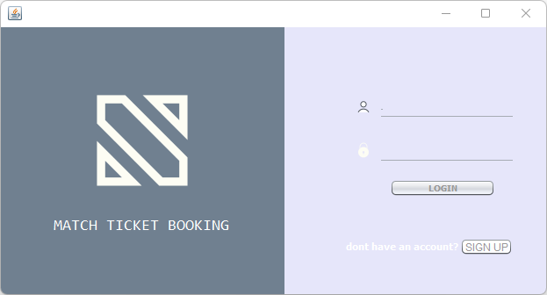

* This login form is made on netbeans, the GUI programming is done through Swing API (Application Programming Interface) enables look-and feel (L & F) environment on JForm. The buttons (Jbuttons) ie. Login and signup are used to execute commands. This form requires two information of the user, the username and the password. The LOGIN button leads the user to the match display form after confirming the details from the database. Whereas, if the admin logs in he would have been able to access the match listings in editing mode as well as the Add Matches Form.
* Whereas if the user doesn’t have an account they need to register themselves first for which they press SIGN UP button which is connected to the sign up form through merely 5 lines of code leading the user to the sign up form.

This form consists of 2 Jpanels, the left panel contains the title and logo of the company, both of which are displayed by text fields ( Jlabel ). The logo is a .png file added in the Jlabel by adding the file from “icon” option in the properties .

The right panel consists of two icons of username and password added in the same way in smaller sizes. The password is hidden using the password field option. The textfields used for Username and the password field used for password is the same color as the background. There are 2 seperators used in the right Jpanel , one below the username textfield and the other below the password field to let the user know where to enter text.

## *Sign Up Form*

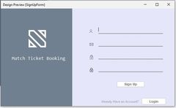

This form collects information of the user needed to register them to allow them to book seats for matches. It stores the information in the database after the user clicks on CREATE ACCOUNT . this form consists of two similar Jpanels . it takes input of users preferable username and password, confirms password and user email and stores it in the database. The icons, logos, textfields and passwordfields are added in the same way as explained in the login form above. Once this information is filled and the user signs up by clicking sign up the account is created and the information is stored in the database. If the user already has an account they click on login button whish leads to the login form.

Match Listings:

Takes values from the assigned database and displays them accordingly, the values are entered into the database by the admin for which we use the admin form. The records here can be updated and deleted by the admin as well.

Booking:

Takes the contact info as the input to use it as an unique ID for sorting and distinguishing purposes. The customer is able to select their preferred seat and know the price of the selected seat.

Payment:

This form allows the user to select their preferred payment method where he enter his card details to proceed with the online mode of payment else they use the proceed button to get his receipt if the user chooses the on-site payment option.

Add Matches:

This a form available to the admin where he is able to add a match.

# CHAPTER 5

## *CODE SNIPPETS*

Class DataBaseConnection

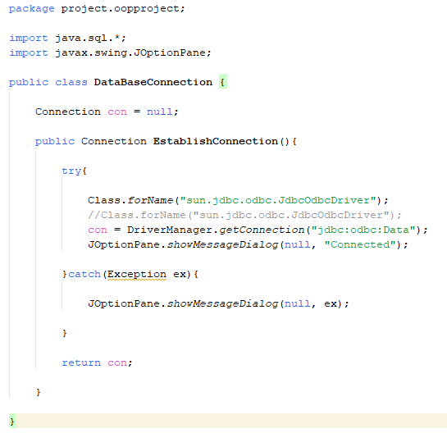

Class Login

Login Form

SignUp Form

MatchListings Form

Bookings Form

Payment Form

Add Matches Form

# CHAPTER 6

6. CONCLUSION

The Match ticket reservation system helps in minimizing the time taking work of manual ticket reservation, which is a hassle and consumes a lot of time that can be utilized somewhere else. Match Ticket Reservation and Cancelling System has been an attempt to help the user minimize his workload along with eliminating all paperwork and saving time. The system has been developed in a way to make it very user friendly. Any person having a little bit of window based can run this system without any hindrance.